These instructions were created to upload minutes to WordPress. This was verified to work on the indicated date in the header.
Minutes are located here: http://www.indyasq.org/meeting-minutes/
- Name the minutes file (e.g. Word, PDF) accordingly. Include “Indy ASQ SLC Minutes,” the year, and the date.
- Access the WordPress site.
- Click on “All Documents” and then on “Add Document” 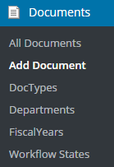
- Enter the title in the title box. Use the following format: SLC Minutes YYYY-MM-DD
- Upload the file from the “Upload New Version” button. Follow prompts.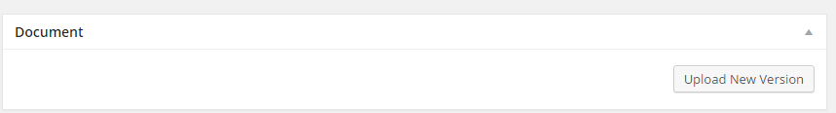
- Click “Edit” on Publish “Visibility” 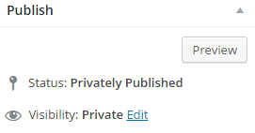.
- Select “Public” and click “OK” 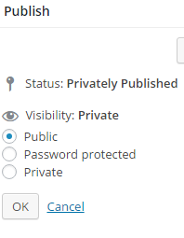
- Set the Doc Type to “SLC Minutes” 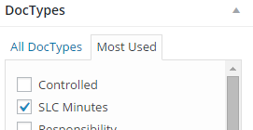
- Set the Department to “Secretary” 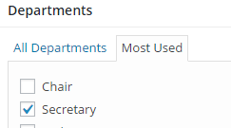
- Select the current Fiscal Year (if the year is not listed select “Add new Fiscal year” follow prompts to add new year). 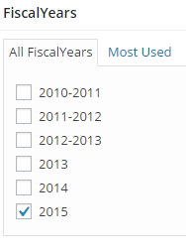
- Set Workflow to “Final” 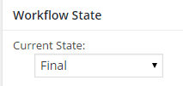
- Click “Publish” to make the document visible and to save all settings. 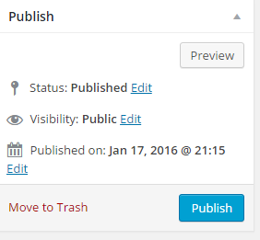
- Open the site to verify that the new minutes are listed.
- If a year changes, add the following code to cause minutes for the new year to be visible. To edit the page there is an edit link at the bottom of the page.
  - Code: YYYY Executive Committee Meeting Minutes
[documents doctype='slc-minutes' fyear='UPDATE TO 4 DIGIT YEAR' numberposts=-1 orderby='title' order='ASC']

